**PROTOCOL ­­­**

**RadEro package  
Version: 1.0.3**

*21/08/2024*

*Created with R v4.4.0 in Windows 11 Pro*

**RadEro package**

*Software name: EroRate*

*Developers: Arturo Catalá*, Borja Latorre*, Leticia Gaspar* and Ana Navas\**

*\*Soil and Water Department, Estación Experimental de Aula Dei (EEAD-CSIC), Spain*

*First year available: 2024*

*Program language: R*

*License: GPL*

EroRate, is a straightforward model to estimate soil migration rates across various soil contexts. Building on the compartmental, vertically-resolved, physically-based mass balance model of Soto and Navas (2004, 2008), EroRate is accessible as a user-friendly R package. Input data, including 137Cs inventories and parameters directly derived from soil samples (e.g., fine fraction density, effective volume), accurately capture 137Cs distribution within the soil profile. The model simulates annual 137Cs fallout, radioactive decay, and vertical diffusion, using a diffusion coefficient derived from 137Cs reference inventory profiles. EroRate also accommodates user-defined parameters as calibration coefficients. The package, code, and test data are openly accessible for widespread use.

**PROTOCOL for the “RadEro_1.0.3_pack” installation folder** *updated in 21/08/2024*

**Folder content:**

* example
  + Folder with example input data files and model execution R file.
* example_solved
  + Folder with example input data files SOLVED with its results files.
* input-config.js
  + *.js* configuration file template
* input-data.csv
  + *.csv* data input file template
* PROTOCOL RadEro v1.0.3
  + This PROTOCOL
* RadEro_1.0.3.tar.gz
  + Compressed package in *.tar.gz* format
* RadEro_1.0.3.zip
  + Compressed package in *.zip* format
* RadEro model.R
  + Model execution R file with INSTALLATION procedure.

**Step 1: RadEro Package installation**

1. Open R, preferably using RStudio with version R v4.4.0 or later.
2. Open the file *RadEro model.R*. This file lists the libraries/packages required to install the RadEro package.
3. Install and load the necessary libraries/packages as specified in *RadEro model.R*.
4. Determine the directory where the file *RadEro_1.0.3.zip* is located.
5. Install the package using the commands provided in *RadEro model.R*.

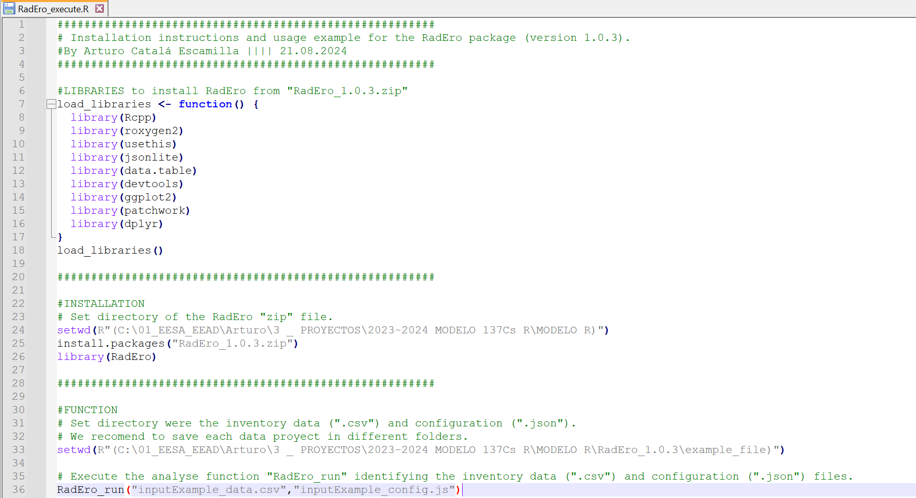**Fig 1.** Screenshot of the *RadEro model.R* content.

To run the model two input files are required: a*.csv* data input file (template: input-data.csv) and a .js configuration file (template: input-config.js). Those must be located in a ***project folder*** as the *“C::/…/RadEro_1.0.3/example”* folder.

**Step 2: Creation of input data file**

To work more practically and intuitively with cells, we recommend opening the *.csv* files in Excel, transforming them as needed, and then exporting them back to *.csv* format.

The template *input-data.csv* shows the structure for the input data, with **predefined columns that MUST NOT be renamed or reordered**:

* **Id**: Sample identification
* **depth_i**: Initial depth of the interval (meters)
* **depth_f**: Final depth of the interval (meters)
* **Cs137_invt**: 137Cs inventory for the interval (Bq/m²)
* **Ref_Cs137_invt**: Reference 137Cs inventory in the study area (Bq/m²)
* **effVol**: Effective volume of the fine fraction at the point (cm³)

**Calculate Effective Volume (Veff) and Fine Particle Density**

Veff (cm³/cm³) = Volume of Fines (cm³) / Total Volume (cm³)

Volume of Fines (cm³) = Total Volume (cm³) - Volume of Stones (cm³)

Total Volume (cm³) = Sample Area (cm²) × Interval Depth (cm)

Volume of Stones* (cm³) = Weight of Stones (g) / Density of Stones (2.65 g/cm³)

*\*Term “Stones” refers to the sample fraction > 2mm.*

For **Sectioned Profiles**: Calculate Veff for each interval and use the average value.

For **Bulk Profiles:** Use the Veff of the entire profile.

* **density**: Density of the fine fraction at the point (g/cm³)

**Calculate Fine Particle Density**

**No Cultivated:**

Density of Fines = Weight of Fines (g) / Volume of Fines (cm³)

**Sectioned Profiles:** Use the density of the first interval. The first interval is affected by soil redistribution processes.

**Bulk Profiles:** Use the density of the entire profile.

**Cultivated:**

Density of Fines = Weight of Fines (g) / Volume of Fines (cm³)

Density = Weight of Fines (g) / Total Volume (cm³)

Explanation: Density is calculated as the weight of fines divided by the total volume of the "device." If stoniness is low, this density is practically equivalent to the one considering the volume of fines.

**Sectioned Profiles**: Use the average density of the intervals included within the ploughing depth defined. Ploughing depth is considered because density is uniform within this mixed depth. Below the plow, the soil profile remains undisturbed, and the radioisotope decreases exponentially with depth.

**Bulk Profiles**: Use the density of the entire profile.

* **k**: The diffusion coefficient, representing the vertical extent of soil affected by diffusion processes (cm²/month), calculated from sectioned profiles. There is a significant difference between natural, undisturbed profiles and cultivated profiles, with the latter having much lower values. Leave this blank if it is a unploughed sectioned reference profile.

The 137Cs method relies on comparing the measured soil 137Cs inventories (total activity per unit area) at a sampling site with a measured inventory from an undisturbed reference site. The reference or control site, which has not experienced erosion or deposition, represents the initial 137Cs deposited in the study region after accounting for its natural decay.

* **e**: Leave this blank; the model calculates it. It represents the migration rate (cm/month), quantifying the net vertical soil movement per month (positive for gain, negative for loss).
* **mix_depth_i**: Upper plough depth (0 meters). Leave this blank if it is an unploughed profile.
* **mix_depth_f**: Maximum plough depth (meters). Leave this blank if it is an unploughed profile.
* **mix_year_i**: Start year of ploughing within the period of 137Cs fallout (minimum year 1954). Leave this blank if it is an unploughed profile.
* **mix_year_f**: End year of ploughing and abandonment of the fields. Is there is any abandonment, this final year is the sampling year. Leave this blank if it is an unploughed profile.
* **mix_frequency**: Annual ploughing frequency (normally set to 1, indicating one ploughing per year). Leave this blank if it is an unploughed profile.
* **lower_boundary**: Total depth used for model calculations (meters). This should be at least 10 cm deeper than the sampling depth. Unless there are impermeable layers, this depth should exceed the sampling depth to avoid boundary condition influence on the calculation. For example, if the sampling depth is 50-60 cm, set the lower boundary to 1.0 meters. Accuracy is not lost by having the boundary condition at a greater depth than the sampling depth.

The *input-data.csv* template contains four example data types: two with sectioned profiles and two with bulk profiles.

* **Ex1**: Sectioned profile, unploughed
* **Ex2**: Sectioned profile, ploughed
* **Ex3**: Bulk profile, unploughed
* **Ex4**: Bulk profile, ploughed

For **sectioned profiles**, the Ref_Cs137_invt, effVol, density, k, e, mix_depth_i, mix_depth_f, mix_year_i, mix_year_f, mix_frequency and lower_boundary of the sampling point should be recorded in the final interval of the profile.

For **bulk profiles**, all data should be recorded in a single row.

**Step 3: Creation of input configuration file**

The template *input-config.js* shows the structure for the input configuration of the model. Parameter fields name **MUST NOT be renamed or reordered**. The **values that can be edited** by the user are marked in **blue** below. For each input data file, there is a corresponding configuration file. If any of the following parameters are not defined in the input data file —Ref_Cs137_invt, effVol, density, k, e, mix_depth_i, mix_depth_f, mix_year_i, mix_year_f, mix_frequency, and lower_boundary— the model will use the values from this general configuration file. However, we recommend defining these parameters in the input data file for each individual point.

"simulate-until-year" : **2003.0**,  *(Year until which the simulation runs)*

"tracer-lifetime" : 28.8811,  *(Radioisotope decay constant, e.g., 137Cs)*

"soil-thickness" : 0.60,  *(Input data parameter =* **lower_boundary***)*

"soil-effective-volume": 1.0,  *(Input data parameter =* **effVol***)*

"soil-density" : 1.0,  *(Input data parameter =* **density***)*

"cell-thickness" : 0.01,  *(Model resolution: recommended: 0.01 m)*

"numerical-cfl" : 0.5, *(Diffusion velocity. Dimensionless time step between 0 and 1)*

"mix-from-depth" : 0.0, *(Input data parameter =* **mix_depth_i***)*

"mix-to-depth" : 0.0, *(Input data parameter =* **mix_depth_f***)*

"mix-interval" : 1.0, *(Input data parameter =* **mix_frequency***)*

"mix-inicial-year" : 0.0, *(Input data parameter =* **mix_year_i***)*

"mix-final-year" : 0.0, *(Input data parameter =* **mix_year_f***)*

"fallout" : *(Specific for each latitude, e.g., 137Cs in the Northern Hemisphere)*

{

"initial-year" : 1954.0, *(Initial 137Cs fallout year)*

"final-year" : 1983.0, *(Final 137Cs fallout year. If Chernobyl (1986) is influential, add years to the curve and additional deposition data)*

"mix-depth" : 0.01, *(Fallout depth of 137Cs. Although in mm, use the maximum cell size)*

"curve" : *(Annual fallout data available, e.g., Northern Hemisphere)*

[

50.0, 150.0, 170.0, 190.0, 320.0,

350.0, 100.0, 140.0, 530.0, 1220.0,

670.0, 290.0, 180.0, 70.0, 70.0,

40.0, 70.0, 70.0, 40.0, 20.0,

40.0, 20.0, 20.0, 30.0, 30.0,

10.0, 10.0, 20.0, 10.0, 10.0

],

"reference-inventory":**1570.0** *(Input data parameter =* **Ref_Cs137_invt***)*

},

"optimization" : *(Sampling domain parameters. READ “****Optimization parameters: k and e****”)*

{

"k-initial" : **0.00**, *(Lower limit of the k value range. See* ***Fig.2****)*

"k-final" : **0.40**, *(Upper limit of the k value range. See* ***Fig.2****)*

"e-initial" : **-0.02**, *(Lowe limit of the e value range. See* ***Fig.2****)*

"e-final" : **0.02**, *(Upper limit of the e value range. See* ***Fig.2)***

*Samples with high erosion or deposit rates, e range limits defined could be small. In that case, the* ***e value in the output results*** *will be equal to the lower or the upper e range limits defined. You has to increase the limits of the e value range(e-initial and e-final) to be able to determine higher redistribution rates.*

***WARNING:*** *Note that if a sample has 0 inventory the 137Cs mass balance model can’t be used. If you introduce a point with no inventory, the model will produce an inaccurate result and an e value in the output that is equal to the upper limit of the e range defined. Don’t confuse this with the previous case.*

"k-samples" : **100**, *(Model resolution that defines the model iterations*

"e-samples" : **100** *To determine the k value in reference profiles, e.g., a resolution of either 100 x 100 (1% error) or 1000 x 1000. To determine erosion and deposition rates with an already defined k (k-samples will be 1), the e-samples parameter is the only one that can be adjusted, e.g., e-samples = 1000 iterations typically yield reliable results.)*

***WARNING:*** *High k and e samples implies high resolutions, which can result in long computation times for the model.* ***Before performing high-resolution analysis, try conducting an exploratory test with a low resolution, such as 100x100.***

}

{

**Optimization parameters: k and e**

Soil redistribution rates are determined by comparing a simulated inventory, generated by the model, to a stable reference inventory assuming no erosion or deposition. Optimal model performance is achieved when the simulated inventory closely matches the measured inventory. Each simulated inventory is defined by two model parameters: the migration rate e and the diffusion coefficient k.

The model identifies the optimal simulated inventory by determining specific k and e values that best fit the input data. To achieve this, a Monte Carlo method is applied to a user-defined **sampling domain of k and e values**. Through numerous iterations, the Monte Carlo simulation generates a finite set of potential inventory values within this defined space (Fig. 1). The model then selects the value closest to the measured inventory, enabling the calculation of the soil migration rate (Mg ha-1 yr-1).

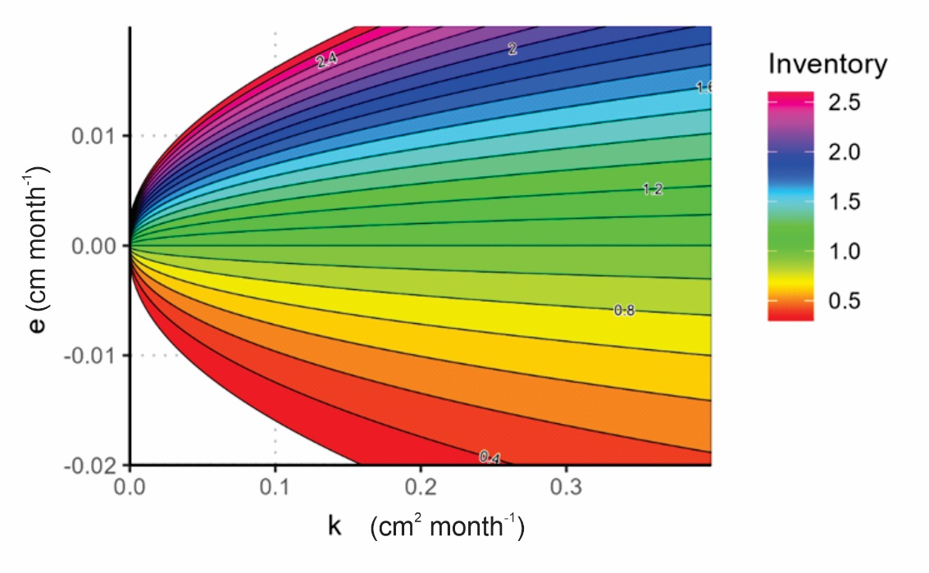**Fig.2** Graphical representation of a sampling domain defined by the range of values for diffusion coefficient k (cm2 month-1), and migration rate e (cm month-1). The model simulates a finite number of potential inventory values within this domain based on the specified number of iterations. Isolines and color-coded areas represent dimensionless inventory values across the workspace.

Before calculating rates for samples, whether bulk or sectioned, it is essential to determine the representative diffusion coefficient for the study area. This coefficient is calculated in the model with input reference profiles that are sectioned and unploughed. In the input file of a reference profile, the columns for k and e will be left blank. The sampling domain (ranges of the possible k and e values where the model can iterate) must be defined by the user in the "optimization" (In Fig.2 those ranges are represented in the axis).

**Step 4: Results files**

Once the calculations are finished, the model will generate the results in the defined working directory (the ***project folder*** defined on the **Step 1**). The example_solved folder demonstrates how the results files are created.

**“results” folder:** Each point analysed will generate a profile plot.png and a temp folder with is corresponding ID. In addition, the whole set of results of all the points will be reported in a results.txt file.

* ID_plot.png : Experimental (blue) and simulated (red) inventory depth profile plots. To represent both inventories on the same scale, they are plotted in Bq m⁻³ per cell unit (m). The right column shows the experimental inventories in blue, displaying the values for each interval in the sectioned profiles or the single value for the bulk profiles. Total experimental and simulated inventory is display below the plot.

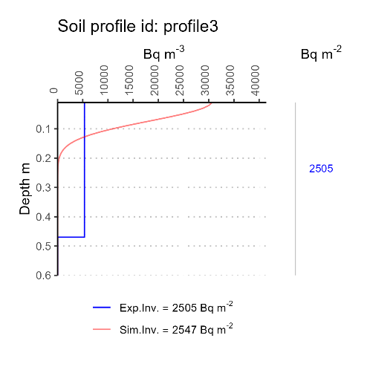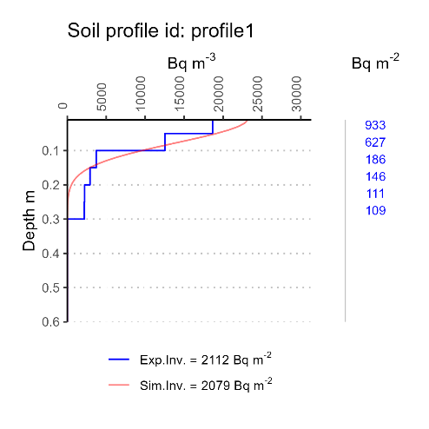

**Fig.3** Example plots from the example_solved folder.

* ID_tempfile : Experimental inventory (Bq kg-1) per cell unit in the profile depth defined.
* results.txt :
  + - id : Point/sample/profile ID
    - e (cm month-1) : Migration rate
    - m (Mg ha-1 yr-1) : Erosion rate
    - k (cm2 month-1) : Diffusion coefficient (estimated with reference sectioned profiles)
    - kv (cm2 month-1) : Diffusion coefficient considering effective volume (k*Veff)
    - Experimental-inventory (Bq m-2) : Total experimental inventory
    - Simulated-inventory (Bq m-2) : Total simulated inventory

**“temp” folder:** Folder for **advanced users** in the 137Cs technique and programming. This temporal folder is created for each profile and recovers temporal files of each individual analysis. All the temporal folders are saved in the results folder with its corresponding ID.

Inner files are:

* _config.js : Specific configuration file created for each sample in the input data.
* _exp.txt : Experimental inventory (Bq kg-1) per cell unit in the profile depth defined.
* _num.txt : Simulated inventory (Bq kg-1) per cell unit in the profile depth defined.
* _num2.txt : Simulated inventory (Bq m-3) per cell unit in the profile depth defined beginning in 0.00 m.
* _num3.txt : Simulated inventory (Bq m-3) per cell unit in the profile depth defined beginning in 0.01 m.
* resultstemp.txt : results file for the profile (see the  **“results” folder** above)
* Other codify files created by C++ code.